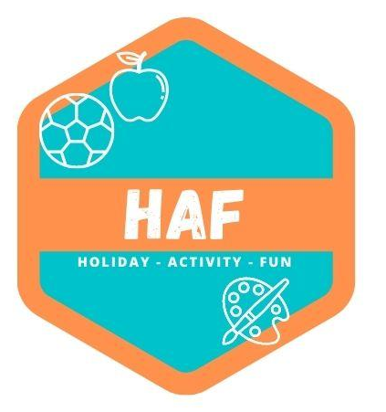

Health and Safety Policy

West Lancs HAF considers health and safety to be of utmost importance.
We comply with The Health and Safety at Work Act 1974 and the Workplace
(Health, Safety and Welfare) Regulations 1992 at all times.
The camp has appropriate insurance cover, including employer’s liability insurance and public liability insurance.
Each member of staff follows the Camp’s Health and Safety Policy and is responsible for:
• Maintaining a safe environment
• Taking reasonable care for the health and safety of themselves and others attending the camp
• Reporting all accidents and incidents which have caused injury or damage or may do so in the
future
• Undertaking relevant health and safety training when required to do so by the camp manager.
Any member of staff who disregards safety instructions or recognised safe practices will be subject to disciplinary procedures.
Responsibilities of the registered person
The registered person for the setting holds ultimate responsibility and liability for the safe operation of the camp. The registered person will ensure that:
• They nominate a Health and Safety Officer.
• The designated health and safety officer is for HAF West Lancs Matt Tuffs.
• A copy of the current Health and Safety at work poster is displayed (poster is available here: http://www.hse.gov.uk/pubns/books/lawposter.htm )
• All staff receive information on health and safety matters, and receive training where necessary
• The Health and Safety Policy and procedures are reviewed regularly
• Staff understand and follow health and safety procedures
• Resources are provided to meet the camp’s health and safety responsibilities
• All accidents, incidents and dangerous occurrences are properly reported and recorded. This
includes informing Ofsted, child protection agencies and the Health and Safety Executive under
RIDDOR (Reporting of Injuries, Diseases and Dangerous Occurrences Regulations 1995) where
appropriate.
• All reported accidents, incidents and dangerous occurrences are reviewed, so that preventative
measures can be taken.

Responsibilities of the manager
The camp manager is responsible for ensuring that at each session:
• Premises are clean, well lit, adequately ventilated and maintained at an appropriate
temperature
• The premises are used by and solely available to the camp during opening hours
• All the Camp’s equipment is safely and securely stored
• Children are only allowed in the kitchen if properly supervised (e.g. for a cooking activity)
• A working telephone is available on the premises at all times
• Chemicals and cleaning materials are stored appropriately, and in accordance with COSHH
data sheets.
• External pathways are cleared in severe weather.
• Daily environment checks are carried out in accordance with our Risk Assessment policy.

Security
Children are not allowed to leave the camp premises during the session unless prior permission has been given by the parents.
During camp sessions all external doors are kept locked, with the exception of fire doors which are alarmed. Staff monitor the entrances and exits to the premises throughout the session.
All visitors to the camp must sign the Visitor Log and give the reason for their visit. Visitors will never be left alone with the children.
Security procedures will be regularly reviewed by the manager, in consultation with staff and parents.
Toys and equipment
All furniture, toys and equipment are kept clean, well maintained and in good repair. We select toys, equipment and resources with care, and we carry out risk assessments before the children are allowed to use them. Broken toys and equipment are disposed of promptly.
We ensure that any flammable equipment is stored safely.
Food and personal hygiene
Staff at West Lancs HAF maintain high standards of personal hygiene, and take all practicable steps to prevent and control the spread of infection.
• A generally clean environment is maintained at all times.
• Toilets are cleaned daily and soap and hand drying facilities are always available.
• Waste is disposed of safely and all bins are kept covered.
• Staff ensure that children wash their hands before handling food or drink and after using the
toilet.

• Cuts and abrasions (whether on children or staff) are kept covered.
Dealing with body fluids
Spillages of blood, vomit, urine and faeces will be cleaned up immediately.

Staffing levels
Staff ratios and levels of supervision are always appropriate to the number, ages and abilities of the children present, and to the risks associated with the activities being undertaken. A minimum of two members of staff are on duty at any time.

This policy was adopted by: West Lancs HAF | Date: 20/03/2023
Reviewed on: 21/06/25  To be reviewed: 21/06/26 | 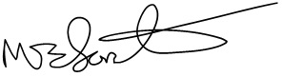  Signed: M.Forster

